2015 SAY SOCCER - OHIO AREA STATE TOURNAMENT
TEAM PRE-SALE SHIRT ORDER FORM
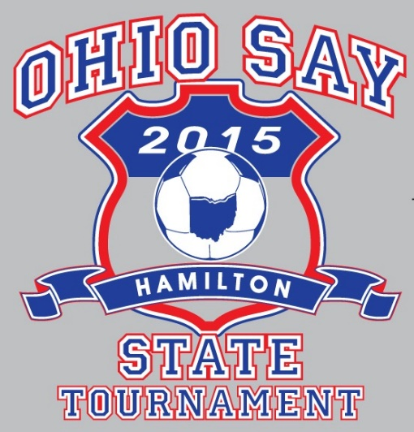
ALL SHIRTS ARE ‘HEATHER GREY’
WITH LOGO AS SHOWN
To place a team pre-sale order: Complete one form, save the file and email to hamiltonsaysoccer@fuse.net.
Telephone orders or questions call 513-896-9143.

CASH OR CHECK PAYMENT FOR THE ENTIRE TEAM ORDER must be made when the order is picked-up
at the shirt sales table behind the concession stand. Make checks payable to Hamilton SAY Soccer.

REQUIRED – ONE ORDER FORM & ONE CHECK PER TEAM.…NO INDIVIDUAL FORMS OR PAYMENTS.

Pre-sale order prices include a savings of $3.00 per shirt.
Limited quantities for individual sale are available at the tournament.

TEAM PRE-SALE ORDER MUST BE RECEIVED BY 8:00PM, SUNDAY, NOVEMBER 8.

Coaches Name: |  |  |  | Contact Name:
Contact Ph: |  |  | Contact Email: |  |  | Team Cost:

Sizes | Hooded  Sweatshirt | Qty | Long Slv  T-shirt | Qty | Short Slv  T-shirt | Qty
Youth Med | $26 |  | $18 |  | $14
Youth Lrg | $26 |  | $18 |  | $14
Adult Sm | $26 |  | $18 |  | $14
Adult Med | $26 |  | $18 |  | $14
Adult Lrg | $26 |  | $18 |  | $14
Adult XL | $26 |  | $18 |  | $14
Adult 2XL | $28 |  | $20 |  | $16
Adult 3XL | $30 |  | $22 |  | $18

TEAM name will appear on the shirt back ONLY IF the coach submitted a program listing before the required deadline.

